**DSP LAB-2**

**AIM: T**o explore the utility of Matlab Script for 1-D signal processing by choosing a suitable input signal for illustration and analysis to experience the mono and stereo modes of an audio signal and the effect of sampling.

**SOFTWARE USED:** Matlab R2019a

**DISCUSSED SCRIPT (SIR’S SCRIPT):**

clc

clear all

[hootie,fs]=audioread('hootie.wav'); % loads hootie.wav

out=hootie;

% channels

left=hootie(:,1);

right=hootie(:,2);

% plotting

figure(1);

time=(1/44100)*length(left);

t=linspace(0,time,length(left));

plot(t,left);

xlabel('time (sec)');

ylabel('relative signal strength');

figure(2);

time=(1/44100)*length(right);

t=linspace(0,time,length(right));

plot(t,right);

xlabel('time (sec)');

ylabel('relative signal strength');

figure(3);

time=(1/44100)*length(hootie);

t=linspace(0,time,length(hootie));

plot(t,hootie);

xlabel('time (sec)');

ylabel('relative signal strength');

% Listen

% pause

soundsc(left,fs); % plays left channel as mono

disp('playing left channel as mono');

pause;

soundsc(right,fs); % plays right channel mono (sound nearly the same)

disp('playing right channel as mono');

pause;

soundsc(hootie,fs); % plays stereo (ahhh?)

disp('playing stereo Ahhh');

pause;

disp('Sampling rate demo');

soundsc(hootie,fs); % Orig?

pause;

disp('Sampling Rate Demo');

soundsc(hootie,fs/2.5); % How slow can you go?

pause;

disp('Sampling rate demo');

soundsc(hootie,fs*3) % !

pause;

**OUTPUT GRAPHS:**

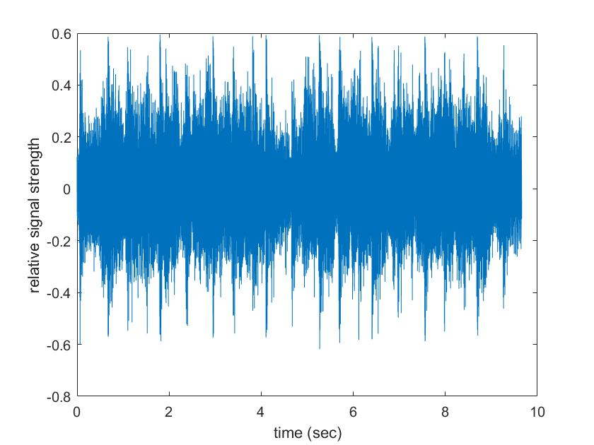   
 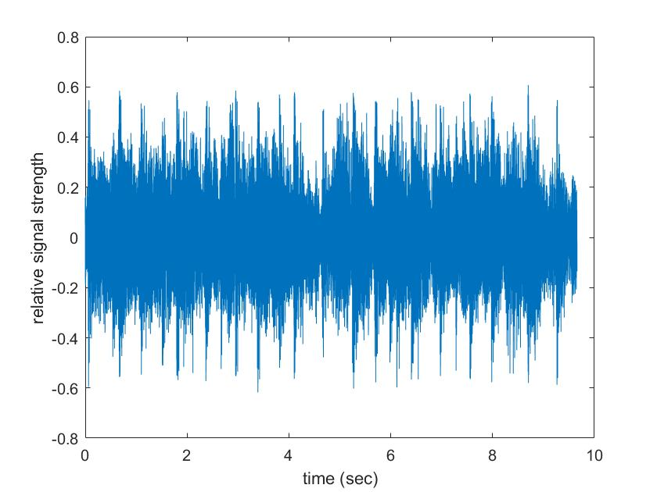

LEFT MONO:

RIGHT MONO:

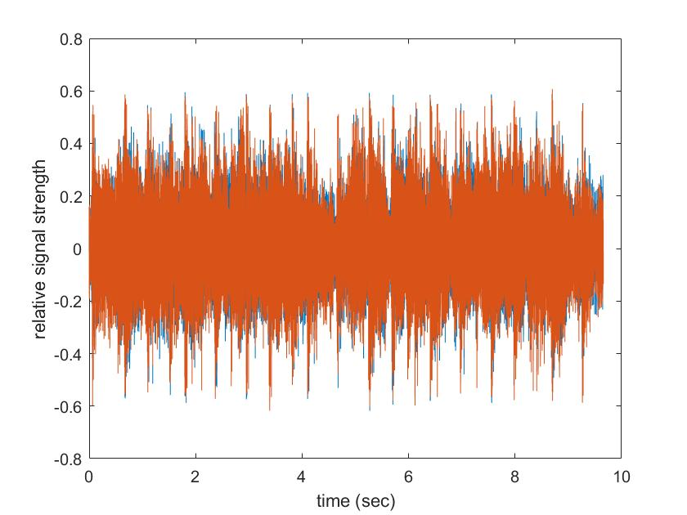

STEREO:

**NEW SCRIPT:**

clc

clear all

% loads 8D_Sugar_and_Brownies.wav

[hootie,fs]=audioread('8D_Sugar_and_Brownies.wav');   
out=hootie;

% channels

left=hootie(:,1);

right=hootie(:,2);

% plotting

figure(1);

time=(1/44100)*length(left);

t=linspace(0,time,length(left));

plot(t,left);

xlabel('time (sec)');

ylabel('relative signal strength');

figure(2);

time=(1/44100)*length(right);

t=linspace(0,time,length(right));

plot(t,right);

xlabel('time (sec)');

ylabel('relative signal strength');

figure(3);

time=(1/44100)*length(hootie);

t=linspace(0,time,length(hootie));

plot(t,hootie);

xlabel('time (sec)');

ylabel('relative signal strength');

% Listen

% pause

soundsc(left,fs); % plays left channel as mono

disp('playing left channel as mono');

pause;

soundsc(right,fs); % plays right channel mono (sound nearly the same)

disp('playing right channel as mono');

pause;

soundsc(hootie,fs); % plays stereo (ahhh?)

disp('playing stereo Ahhh');

pause;

disp('Sampling rate demo');

soundsc(hootie,fs); % Orig?

pause;

disp('Sampling rate demo');

soundsc(hootie,fs/2.5); % How slow can you go?

pause;

disp('Sampling rate demo');

soundsc(hootie,fs*3) % !

pause;

**OUTPUT GRAPHS:**

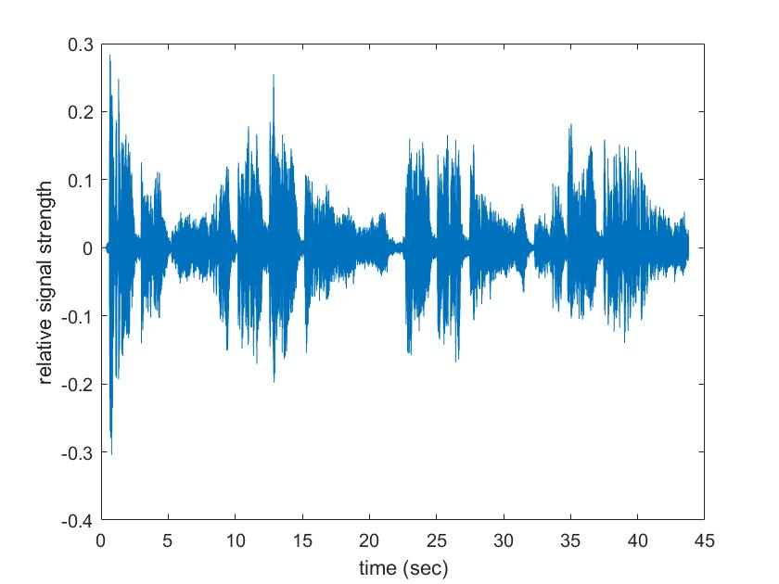

LEFT MONO:

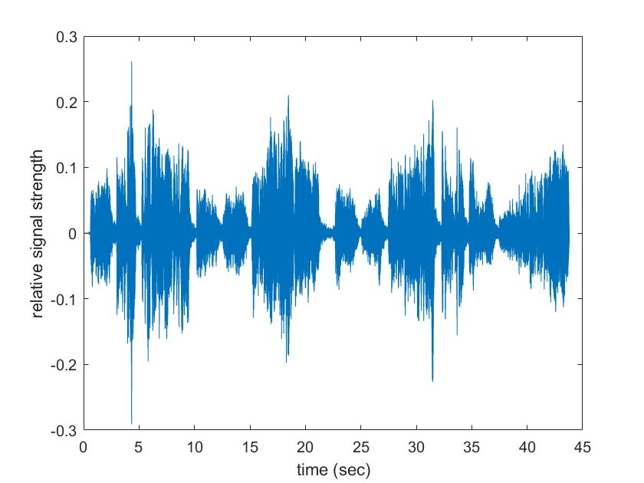

RIGHT MONO:

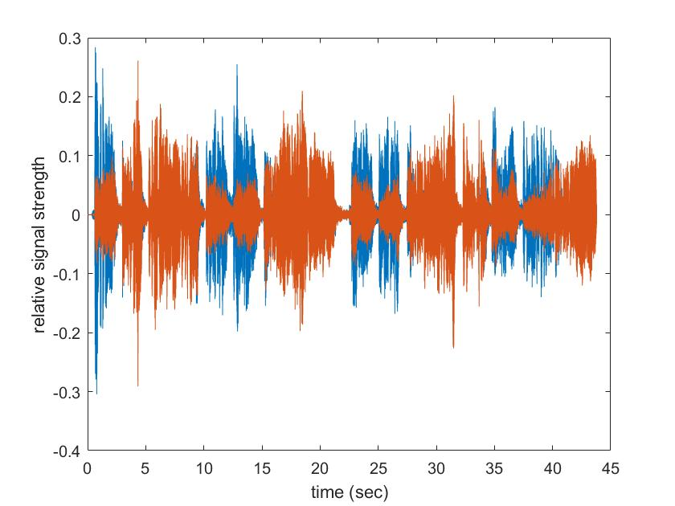

STEREO:

**OBSERVATIONS:**

1. The sound that we listen to from left and right mono channel is significantly the same. It does show a difference when we look at the graph, but it is difficult to differentiate between them while listening. The stereo sound of the original script was the mix of both left and right mono channels, and it was very similar to the mono audio sound.
2. The sound file (.wav) which was used in the new script was first converted to 8D via a software. Further, when we run the .wav file, there is a significant difference in the sound that comes out of left and right mono channel. It can be easily differentiated by listening to it. The stereo mode sound of the new script was significantly different from the mono channel audio. It had a surround sound effect.
3. When the rate of sampling was decreased by a factor greater than one, the sound played that was being played was very slow as compared to the old audio. It had a protracting effect and the same file took more time to complete its playing. It was because the number of samples taken for the sound were comparatively very less.
4. When the rate of sampling was increased by a factor greater than one, the song was faster than the original. It happened because there were more number of samples taken per second and therefore we can say that the graph was compressed on the x-axis.

**REAL LIFE UTILITY:**

1. We often get to hear about stereo sound when we speak about amplifiers and home theatre. This is because of the technology used in it. The Dolby Atmos 5.1 or the Dolby Atmos Surround Sound are the examples of it. It depends on the number of mono channels from which the sound is produced.
2. We have the option of increasing the number of samples or even changing the mode of sound in the Amplifier, i.e, for eg: “Vienna Hall”, “Munich Hall”, “Adventure”, “Opera”, etc are some of the modes available. These are changed by changing the number of channels and also by changing the number of sample outputs from each of the channels.
3. In the headphones, we often see the tags of acoustic surround sound. In that, we have the ability to change the channel from which we specifically want the output.
4. Most places who play music and use mono today are clubs, restaurants, and bars that have a lot of speakers that are directed in too many different ways, so they can’t define what speakers are the left ones and what are the right ones.

**CONCLUSION:**

* **Sample Rate/Sample Frequency** is the number of samples per unit time. Higher sample frequency obtains a signal which is similar to original analog signal for good audio quality.
* Stereo channels send two signals, one for each speaker. It uses two different channels, one for the left speaker and one for the right speaker.
* You can use stereo channels to create directionality, perspective, and a simulation of real space. But, the primary use of stereo signals today is creating width.
* When we decrease/increase the samples taken per second in the audio, it becomes slow/fast respectively.